
AI CAREER FOR WOMEN
Commerce

Impact of Artificial Intelligence on
Usage Patterns and Digital Trends

A Project Report
submitted in partial fulfillment of the requirements
of
AICW project.

by

Priyanshi Patel, priyanshi170206@gmail.com
Aayushi Soni, aayushisoni8910@gmail.com
Vruti Patel, vrutipatel509@gmail.com

Under the Guidance of
Jyoti Mam

ACKNOWLEDGEMENT

We would like to take this opportunity to express our deep sense of gratitude to all individuals who helped us directly or indirectly during this thesis work.

Firstly, we would like to thank my supervisor, Jyoti Mam and Radha Mam, for being a great mentor and the best adviser we could ever have. Their advice, encouragement and the critics are a source of innovative ideas, inspiration and causes behind the successful completion of this project. The confidence shown in me by them was the biggest source of inspiration for us. It has been a privilege working with them for the last one year. They always helped me during my project and many other aspects related to the program. Their talks and lessons not only help with project work and other activities of the program but also make us a good and responsible professional.

ABSTRACT of the Project
Artificial intelligence (AI) has rapidly become a key part of digital platforms and online services, influencing how users interact with technology. With the increasing adoption of AI-based tools between 2023 and 2025, usage patterns and digital trends have changed significantly. However, there is limited clarity on how AI impacts daily and monthly internet usage, how digital behavior varies across different user categories, and how aware users are of AI-related risks and costs.
The objective of this project is to analyze usage patterns and digital trends during the period from 2023 to 2025 and to evaluate the overall impact of artificial intelligence on users. The project also aims to identify changes in internet usage behavior, compare trends among different user groups, and assess user awareness regarding the risks and costs associated with AI technologies.
The methodology used in this project includes the analysis of real-world data collected from surveys, usage reports, and publicly available digital trend sources. Data analysis techniques are applied to observe patterns, identify variations in user behavior, and understand the influence of AI-driven applications on internet usage.
The results of the study show a steady increase in internet usage linked to AI-powered services, along with noticeable changes in digital habits across different user categories. The findings also indicate that while AI adoption is growing, user awareness of potential risks and costs remains uneven.
In conclusion, the project highlights the growing influence of artificial intelligence on usage patterns and digital trends. The insights gained from this study can support better decision-making, responsible AI adoption, and improved user awareness in an increasingly AI-driven digital environment.

TABLE OF CONTENTS
Abstract
List of Figures
Chapter 1. Introduction
1.1 Problem Statement
1.2 Motivation
1.3 Objectives
1.4. Scope of the Project
Chapter 2. Literature Survey
Chapter 3. Proposed Methodology
Chapter 4. Implementation and Results
Chapter 5. Discussion and Conclusion
References

Abstract

- This project studies Artificial Intelligence on AI Usage Patterns and Digital Trends during the period 2023 to 2025.
- The objective is to understand how AI has influenced user behaviour, internet usage, digital consumption, risk perception, and cost trends.
- The analysis is based on data collected from 300 respondents across multiple countries and age groups.
- Using Power BI, the data was visualized through interactive dashboards to identify patterns, trends, and key insights. The findings reveal a steady increase in AI adoption, significant changes in user usage patterns, and growing awareness of AI-related risks.
- This project highlights the evolving role of Artificial Intelligence in shaping modern digital lifestyles.

LIST OF FIGURES
 |  | Page No.
 | Increase in AI Risk Concern over Time | 8
 | AI Familiarity by States | 8
 | High AI Risk Perception by Age Group | 8
 | Monthly Internet usage Distribution across Cities | 9
 | Monthly Internet Usage Cost by User Category | 9

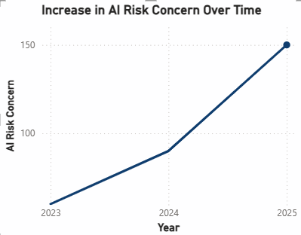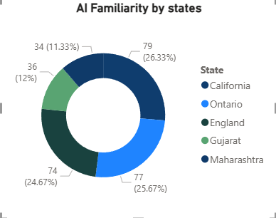
This donut chart illustrates AI familiarity across different states. Some states show higher AI awareness, indicating regional differences in technology adoption.
This line chart shows the increase in AI risk concern from 2023 to 2025. The trend indicates that users are becoming more aware of potential risks associated with Artificial Intelligence over time.

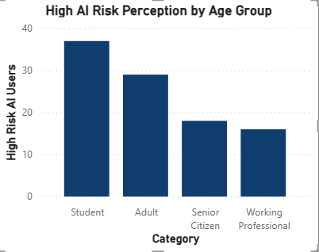
This bar chart represents AI risk perception across age groups. Students and adults show higher concern levels compared to seniors and working professionals.
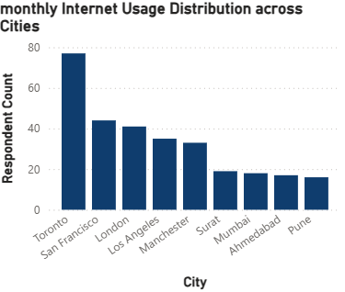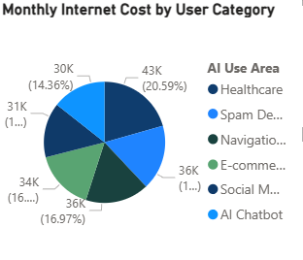
This chart displays the distribution of monthly internet costs among different user categories. Heavy AI users tend to have higher internet expenses.
This chart shows how internet usage varies across cities. Metro cities have higher internet usage due to greater digital dependence and AI tool adoption.

CHAPTER 1
Introduction
1.1 Problem Statement:
With the rapid growth of Artificial Intelligence, usage patterns and digital behaviour is changing continuously. However, there is limited understanding of:
- How AI adoption affects daily and monthly internet usage
- Changes in digital trends across different user categories
- User awareness regarding AI risks and costs
This project aims to address these challenges by analysing real-world data to identify trends, risks, and the overall impact of AI on users between 2023 and 2025
1.2 Motivation:
The motivation behind this project is the fast growth of AI technologies and their influence on everyday life. Students and professionals increasingly rely on AI tools, which changes how they use the internet and digital resources. Despite this, there is not enough analysis of how AI affects internet consumption, financial cost, and user awareness of risks. Understanding these changes is important for responsible AI usage. This project helps in identifying usage trends and raising awareness about both benefits and potential risks of AI in digital environments.
1.3 Objective:
The main objectives of this project are:
- To study AI usage trends from 2023 to 2025
- To analyze the impact of AI on internet usage
- To understand changes in digital costs due to AI use
- To evaluate user awareness of AI-related risks
- To visualize data using Power BI dashboards

CHAPTER 2
2.1 Review relevant literature or previous work in this domain:
Many researchers have studied the growth of Artificial Intelligence and its impact on modern society. Studies show that AI tools are widely used in education, business, healthcare, and daily digital activities. Research indicates that AI improves productivity and makes tasks faster and easier. Several reports highlight that AI adoption is increasing every year due to easy access to AI-based applications and internet services. Previous studies also discuss how AI influences user behavior, such as increased screen time, higher internet usage, and dependence on digital platforms. Some research focuses on AI risks, including data privacy issues, misinformation, and ethical concerns. These studies help in understanding the general influence of AI on digital life.

2.2 Mention any existing models, techniques, or methodologies related to the problem:
Earlier research mainly used surveys, data analysis tools, and statistical methods to study AI usage patterns. Many studies used visualization tools to understand user trends and technology adoption. Some researchers applied data analytics to measure internet usage growth and digital behavior changes. However, most studies focused only on AI benefits or risks separately. Very few studies combined AI usage trends, internet consumption, cost impact, and risk awareness in a single analysis. This shows a need for more comprehensive studies.

  - Highlight the gaps or limitations in existing solutions and how your project will address them:

Although many studies discuss AI growth, there is limited research connecting AI adoption with internet usage patterns and digital costs together. Few studies analyze how user awareness of AI risks changes over time. Most research does not provide clear visual dashboards to understand trends easily. Therefore, there is a gap in combining user behavior, cost factors, and risk perception using visualization tools. This project addresses that gap by using Power BI to analyze survey data and present insights through interactive dashboards.

CHAPTER 3
The system is designed to analyze the impact of Artificial Intelligence on user behavior, internet usage, cost, and risk awareness. Survey data is collected from users and imported into Power BI. The data is then cleaned and organized. After processing, the data is analyzed to identify patterns and trends. Finally, the results are presented using dashboards, charts, and visual reports. The system allows easy understanding of AI usage trends and digital changes over time.
3.2 Modules Used
The project is divided into the following modules:
Data Collection Module – Survey data from users
Data Processing Module – Cleaning and organizing data in Power BI
Data Analysis Module – Studying trends and patterns
Visualization Module – Creating charts and dashboards
Reporting Module – Presenting results and insights
3.3 Data Flow Diagram
The data flow in the system follows these steps:
User Survey → Data Import into Power BI → Data Cleaning → Data Analysis → Dashboard Visualization → Insights and Conclusions.
This process shows how raw data is converted into useful information.
3.4 Advantages
Easy understanding of AI usage trends
Visual representation of complex data
Helps identify risk awareness levels
Shows relationship between AI usage and internet cost
Useful for academic and research purposes
3.5 Requirement Specification
3.5.1 Hardware Requirements
Computer or laptop
Minimum 4GB RAM
Internet connection
3.5.2 Software Requirements
Microsoft Power BI
Microsoft Excel (for dataset)
Windows Operating System

CHAPTER 4
Implementation
The implementation of this project was carried out using Microsoft Power BI. The survey dataset containing information about AI usage, internet consumption, cost, and risk awareness was imported into Power BI. The data was cleaned by removing errors and organizing columns properly. After data preparation, relationships between variables were analyzed. Different visualizations such as line charts, bar charts, pie charts, and donut charts were created. Filters and slicers were used to compare data across years (2023–2025). The dashboard was designed to clearly show trends, patterns, and comparisons. This implementation helped convert raw data into meaningful visual insights.
4.1 Results of the Analysis
The analysis shows that AI usage has increased steadily from 2023 to 2025. As AI adoption grows, internet usage and digital costs also increase. Students and working professionals are the major AI users. The study also shows a rise in awareness of AI-related risks over time. Regional differences in AI familiarity were observed, indicating that some areas adopt AI faster than others. The results suggest that AI is significantly influencing digital behavior and online activity patterns. Overall, the dashboard helps in understanding the relationship between AI growth, digital trends, and user awareness.

CHAPTER 5
Discussion and Conclusion

5.1 Key Findings
The project reveals that Artificial Intelligence usage has significantly increased over recent years. Increased AI adoption is linked with higher internet usage and digital spending. Students and professionals are the most active AI users. The analysis also shows growing awareness about AI risks such as privacy and security concerns. The dashboard clearly indicates that AI is reshaping digital behavior patterns and influencing how people interact online.

https://github.com/priyanshipatel170206-del/Priyanshi-Patel.git

5.4 Limitations
Data is based on survey responses, which may contain bias

Limited sample size
Analysis is restricted to selected years
Results depend on accuracy of user-provided data

5.5 Future Work
Increase dataset size for better accuracy
Include more regions and age groups
Add predictive analysis using AI models
Integrate real-time data sources

5.6 Conclusion
This project successfully analyzes the impact of AI on usage patterns and digital trends. The dashboard provides clear visualization of AI growth, internet usage, cost changes, and risk awareness. The study shows that AI is playing a major role in shaping modern digital life. The project can help researchers, students, and organizations understand AI’s influence on society.

REFERENCES

Kaggle: https://share.google/3pBPeNoFFZgRbNMzl

